# Running for President

It is nearly then end of the presidential elections and the existing president is not able to stand for re-election, so the elections have taken place and two leading candidates have been discovered, however the gap between them is too small for anyone to be sure who will win the final vote so they need to go back on the campaign trail and persuade more people to vote for them.

The objective of the game is for the players to navigate their way through the game board collecting votes along the way until they have enough to become president, this can either be a straight race or they can use positioning tactics to block their opponents moves or force them onto squares where the votes have already been collected.

The players can name their characters to reflect current elections, for example Hilary Clinton & Donald Trump (USA), or François Fillon and Marine Le Pen (France) (Devellennes 2016), or perhaps people they know who are standing for a student union election.

At the end of the game if the players wish to play again using the same charters but with the previous winner as the incumbent, they can give one player an advantage depending on whether the incumbent had been a good president or not.

# Ruleset

1. Eligible for 2 players.
2. Players start at the bottom of the game world.
3. Players roll a six sided die, landing on 1-2 equals one move, 3-4 is two moves and 5-6 is three.
4. The players move between intersections and not inside the squares.
5. At each intersection there is a counter representing one vote.
6. When a player lands on a counter they remove it from the game board, this is known as an internal economy (Adams & Dormans 2012 p60).
7. The players have to collect a minimum number of points to get past the Yellow, Blue and Orange gate boundaries. The yellow gate requires eight votes, blue is 20 and orange is 40.
8. All collectable counters are colour coded to their section on the game board.
9. All gate boundaries are one way only and players cannot turn back to collect votes from the previous section of the board.
10. If a player lands on the other, they each have to roll a die once, whoever has the largest score drains two votes away from the other player’s collected votes (Adams & Dormans 2012 pp62-63).
11. No player can have a negative number of votes.
12. The winner is the first player with 40 votes to reach the top of the game board.

# Game world

The game board shown in figure 1 is a 12x11 board

The players start at the bottom on any unoccupied intersection shown with the black starting points.

The yellow, aqua blue and orange lines represent one of the core mechanics called regional gating (Hauteville 2011) / lock and key system (Adams & Dormans 2012 pp247-250).

The player needs to collect enough votes in order to pass the coloured lines and gain access to the section.

Figure 1

# Game contents

1. One game board sized 31cm x 29.7cm
2. 30 yellow counters ( 22 for game board, 8 spare ) (figure 2)
3. 30 blue counters ( 22 for the game board, 8 spare )(figure 3)
4. 40 orange counters ( 33 for game board, 7 spare )(figure 4)
5. 6 coloured player pieces ( two to be used each game)(figure 5)
6. 1 six sided die (figure 6)



Figure 2

Figure 4

Figure 3

# 

Figure 6

Figure 5

# Game Mechanics, Play Tests & Iterations

After constructing the game, I asked some friends, fellow students and family members to play it whist I made notes. Afterwards I took further suggestions from the players on how to improve the game.

I observed that when a player got lucky with their dice roll and their opponent didn’t, the game quickly became one sided, causing dissatisfaction for one player, this occurred because this game mechanic relies of chance rather than strategy.

So my first iteration is to remove the dice rolling mechanic and replace it with a choice of two move profiles, which the players select before the game commences.

* Profile 1: move up/down 1 or 2 spaces or 1 space left/right
* Profile 2: move up/down 1 spaces or 1 or 2 space left/right

This new rule allowed both players to think about move strategy, before the game commenced and throughout the game and removed the chance element, (Adams 2010 p325).

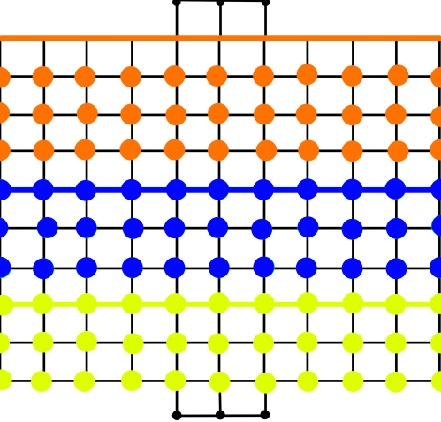With this new rule in place it frequently transpired that a player could move but could not collect any votes as they were landing on the boundary between two zones.

So my next iteration is to add one whole row of colour coded counters to the yellow and blue boundaries, as shown in figure seven.

This iteration allowed the players to use their chosen move profile more effectively, but did require 11 more yellow and blue counters to be added to the game contents.

Figure 7

During further play-test with this iteration, players commented, that with all counters having the same value, they had to collect a considerable number in order to complete the game, therefore the one vote per counter system wasn’t really working as an internal economy.

I therefore changed the values for the blue counters to 2 votes and orange to 3 votes, whilst leaving yellow at 1, this iterated then made it too easy to get past the boundaries and was ineffective towards gameplay.

So I increased the values of the blue boundary to 30 and orange boundary to 70, so they were then high enough to challenge the players. (Hauteville 2011).

With this iteration, I noticed that the players didn’t need to attack each other because there where more than enough counters for both players to collect on the game board, which had turned the game into a race to the top of the board without the need to interfere with one another which negated this part of the game play.

So I further increased the boundaries to 20 votes for yellow, 60 votes for blue and 100 votes for orange (Adams & Dormans 2012 pp247-250), this resulted in the players having to encounter each other a lot more often in order to progress through the levels.

However this often resulted in stalemate as the encounter incentive wasn’t large enough get past the boundaries, and could be easily lost at the next encounter, so I iterated the player encounter rule by changing the winning rewards to two votes for the yellow section, four votes for the blue and six for the orange (Shell 2008 p177). The winning player then drains these votes from the losing player’s total votes (Adams & Dormans 2012 pp62-63). With this iteration the players were encouraged to attack each other for more votes, but as play-test went further problems were encountered.

When one of the players passed through a boundary, the opponent was often left with not enough collectable votes in order to follow them, so was then not able to progress (Adams & Dormans 2012 p69) resulting in negative feedback (Adams 2010 pp350-351).

To stop this from happening I introduced a two-step grinding mechanic to the game (Adams 2010 p325).

1. 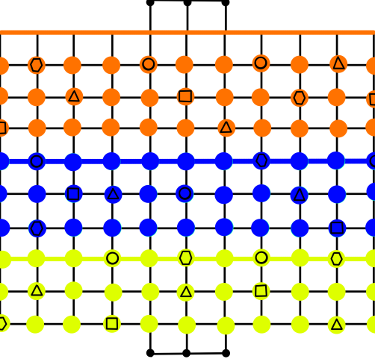As soon as a player passes through a gate all the remaining counters in the lower section double in value.
2. After one further move by both players all of the counters previously collected are replenished still at the higher value

This made it easier for the loosing player to collect the votes needed to pass through to the next section and catch up with their opponent; however this required even more yellow and blue counters to be added to the game contents, in both cases 66 for the game board and 14 spare.

Figure 8

After adding this new grinding mechanic the players started to get bored with just collecting counters so I decided to add positive and negative move variables to some of the intersections, once the counters were come into effect when the counter is removed from the board.

The variables are listed below and shown on Figure eight

1. An extra move up/down (Triangle)
2. An extra move left right (Square)
3. Minus a move left/right (Circle)
4. Minus a move up/down (Hexagon)

Note: - a player can only add variables to a maximum of 3 and only be negated to 1 in any direction.

With this final iteration included there was a little more tension between the players as they used strategy to get the bonuses.

The game then flowed well and soon there was a winner, after which they wanted to play again, so I added a simple throw of the dice to decide if the winner had been a good president or not, with the highest throw winning, and the winner getting a 6 point head start for the second game.

# Bibliography

Hauteville, C. (2011). *Gating.* Available: <https://goo.gl/cxO1oq>. (Last accessed 3rd Jan 2017 ).

Adams, E & Dormans, J. (2012). Common Mechanisms. In: Johnson, J & Wimpsett, T *Game Mechanics Advanced Game Design*. United States: New Riders. p140-142.

Adams, E & Dormans, J. (2012).Internal Economy. In: Johnson, J & Wimpsett, T *Game Mechanics Advanced Game Design*. United States: New Riders. p60-69.

Adams, E & Dormans, J. (2012).Progression Mechanisms. In: Johnson, J & Wimpsett, T *Game Mechanics Advanced Game Design*. United States: New Riders. p247-257.

Adams, E. (2010). Game Balancing. In: Adams, E *Fundamentals of Games Design*. 2nd ed. United States: New Riders. p324-326.

Schell, J. (2008). Game Mechanics Must be in Balance. In: Morgan Kaufmann *The Art of Games Design*. Burlinton: Elsevier. p171-180.

Adams, E. (2010). Game Balancing. In: Adams, E *Fundamentals of Games Design*. 2nd ed. United States: New Riders. p349-351.

Devellennes, C. (2016). *French election 2017 meet the candidates.* Available: https://goo.gl/w0vKVj. Last accessed 16th Jan 2017.